Anthill Plugin Instructions.

**1. Connection**

You will need to obtain the installation, username and API key from Anthill to connection to the relevant Anthill installation.

For support, please email support@anthill.co.uk

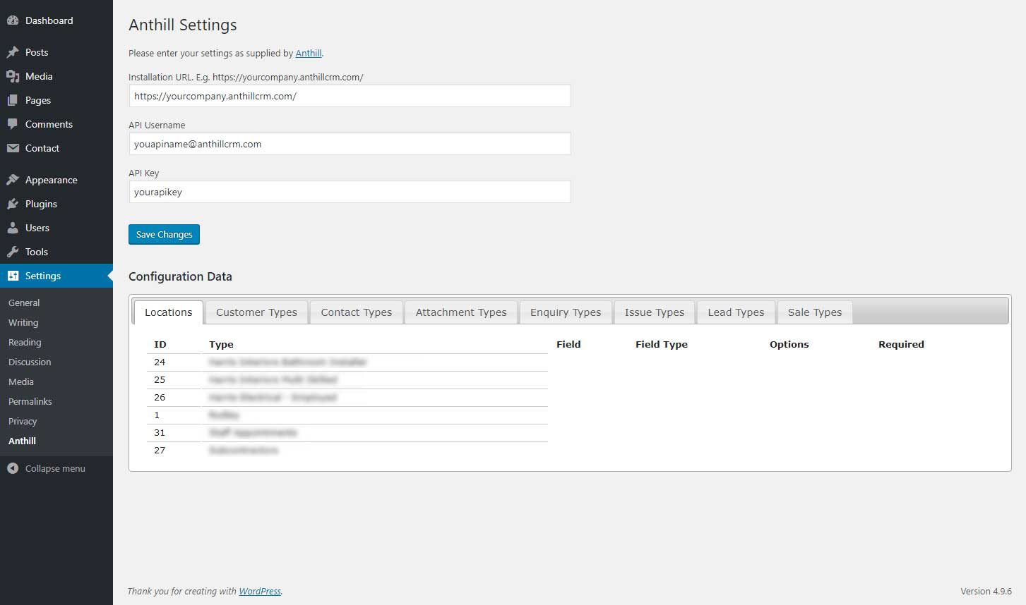

**2. Gravity Forms**

**Form configuration**

**Associate the form post with the configuration stored in Anthill.**

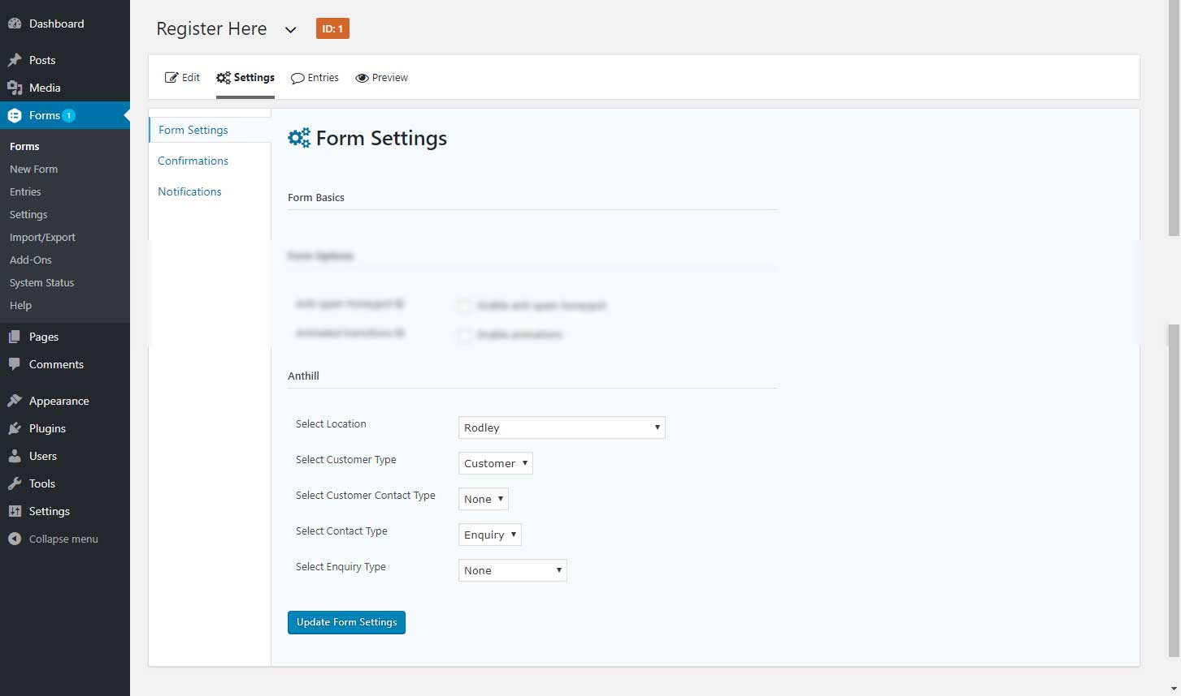

Field configuration

Connect the form fields with custom fields stored within Anthill

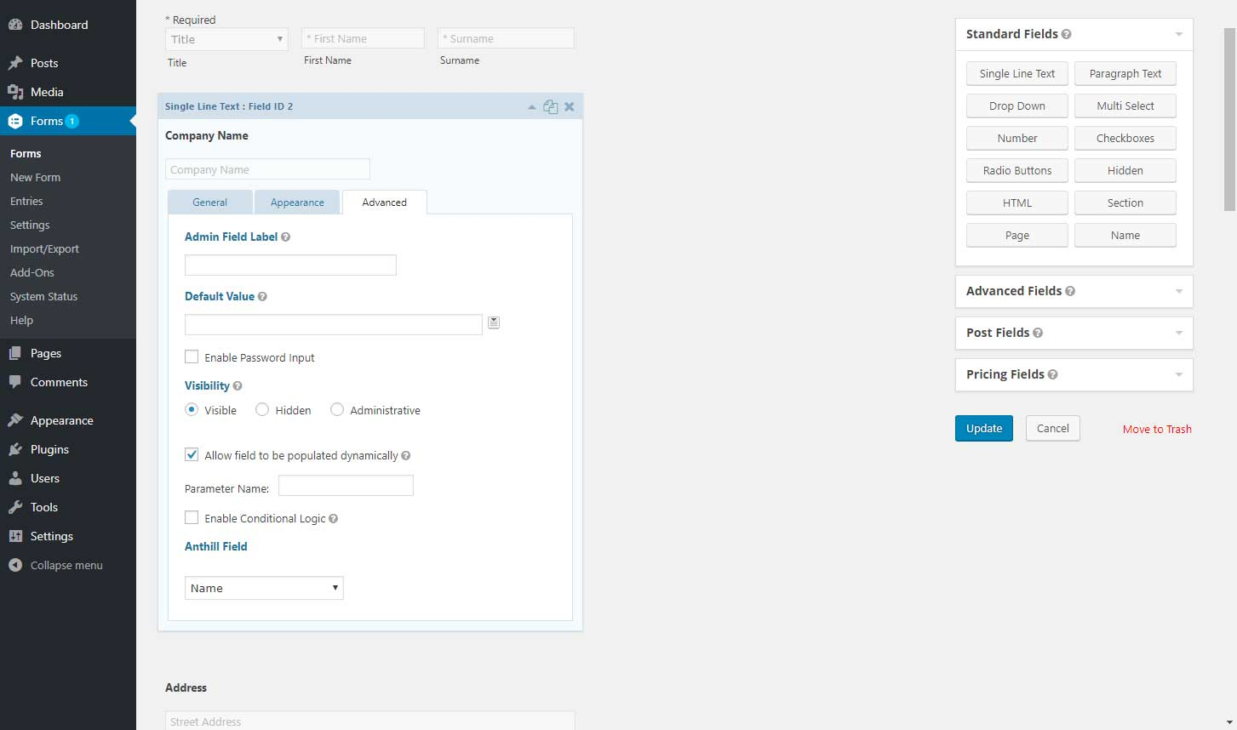

**2. Gravity Forms**

**Form configuration**

**Associate the form post with the configuration stored in Anthill.**

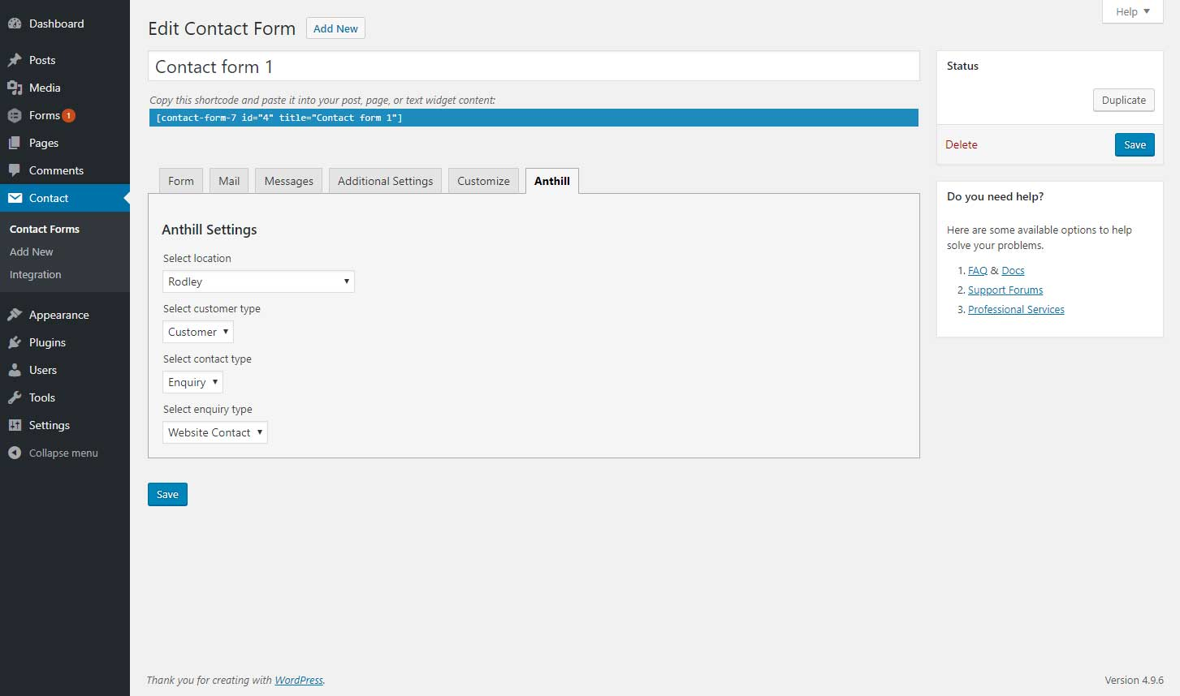

Field configuration

Connect the form fields with custom fields stored within Anthill

